“Still Moving” - Music for Weddings - CD Wedding Gifts
www.lightformfilms.com/WeddingMusic.html

(To listen to all the songs on this CD, go to the webpage above, and click on the song links.)

“Still Moving” Wedding CDs are packaged in either of two types of cases: Trimline Cases or Jewel Cases. Trimline Cases have a single, two-sided graphic for the Front Cover and the Inside Front Cover. Jewel Cases are a little thicker and have 2 separate, two-sided graphics: A two-sided Cover (front and inside) and a two-sided Back (back and inside). The Back Cover wraps around the edges of the Case and provides a Name and Title along the edge of the case.
Just below you will see the design choices that you have for your CD and Case. The first 5 designs are standard designs. At the far right is a sample custom design. The custom design requires that we receive a digital photograph of the couple to be married. The image will be printed on the CD, and if desired, on the Front Cover as well.
The top 3 images are used for Trimline Cases. All 5 images are used for Jewel Cases.
Custom Designs can be done in any of the 5 color motifs. To produce an excellent custom design requires that the couple submit a digital photograph (1.5 Mb minimum size) of themselves. The photograph requires some space to the left and right of the couple to allow for the typesetting. For best results, the background should be somewhat monotone. Dark is ideal, but if the background is light, it should not be busy or contain too many colors.

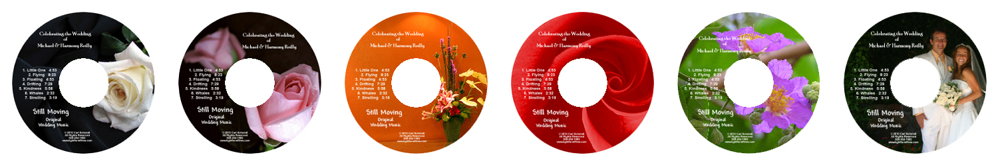
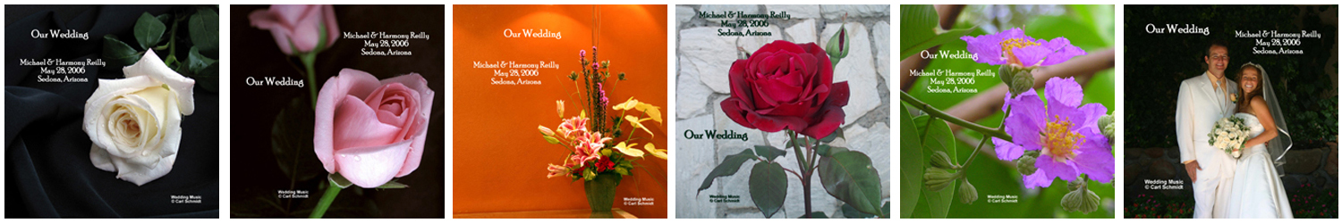
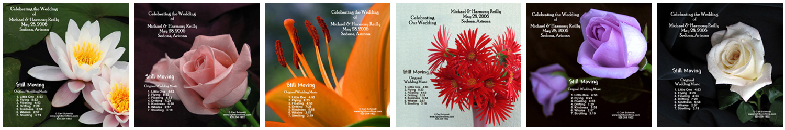
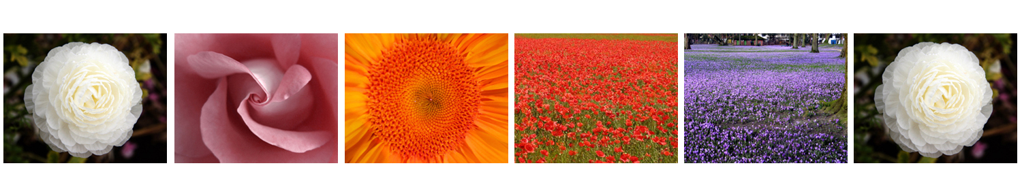
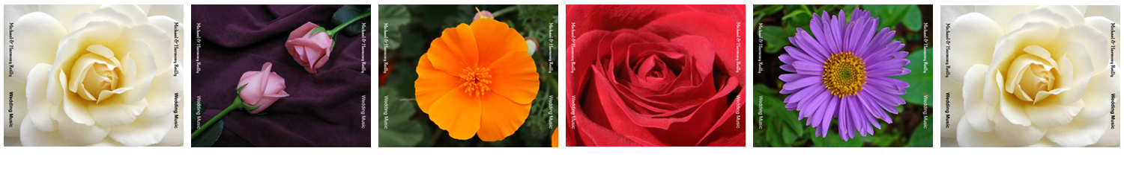
“Still Moving” - Music for Weddings - CD Wedding Gifts
www.lightformfilms.com/WeddingMusic.html

Pricing Information

Quantity | Unit Price with | Unit Price with | Set up Fee for
of CDs | Trimline Case | Jewel Case | Custom Image
5 - 9 | $9.50 | $10.00 | $20.00
10 - 19 | $8.50 | $9.00 | $10.00
20 - 49 | $7.50 | $8.00 | no fee
50 - 99 | $7.00 | $7.50 | no fee
100 or more | $6.50 | $7.00 | no fee

Arizona customers add 10% sales tax. No sales tax for purchases shipped outside of Arizona.
There is no shipping charge for your Wedding CDs (when all are shipped to one location in US).

We can ship your individual CDs to separate locations within the US at a nominal fee, when you provide us with names and addresses in a digital file (Email, Word Document, etc.).

Ordering Information

If you are ordering your CDs through a Wedding Planner or a Wedding Officiant, discuss your selection with them, and he or she will submit the Pre-Order with us. If you wish to make your Pre-Order directly with us, proceed as follows.
When you have decided on the style (Design, Color, Style of CD Case, and the placing of the songs in a specific order on the CD) for your Wedding CDs, go to our website:
www.lightformfilms.com/WeddingMusic.html

and click on the “Pre-Order CDs” link on that page. Fill out the form with all the pertinent information and click “Submit”. This sends your order to us directly. We will then contact you about any custom details that are required, and any questions we might have regarding your order. When all the details are clear, we will advise you of the total for your order. Once we receive full payment, we will prepare your CDs and ship them to you immediately. Delivery time normally is within 1-2 weeks, depending on the size of your order and any custom work that is required.

Carl Schmidt
Light Form Films
132 Willow Way
Sedona, AZ 86336
928-204-1902
carl@lightformfilms.com

